Collecting User Acquisition Data Through all Channels

Website/SEO Assignments

NAME: Tahiya Rahman

horizontal line

# About the Data

The purpose of the paper is to find out trends in User Acquisition through all the channels over different time periods within year 2022 to year 2023 in NSTEM. The data will show the potential best channels for the user acquisition.

Comparison of Data over time and trends

July 1st, 2022 - December 31st, 2022 —-----------------------------------------------------------------------------------------------

* Most users are getting the website information through organic search and Direct marketing. From the Multi-Channel Funnel (MCF) reporting overview from the Google Analytics platform, the conversions show the potential channels as the Direct Marketing Channel, a 62.28% of conversion rate in NSTEM.

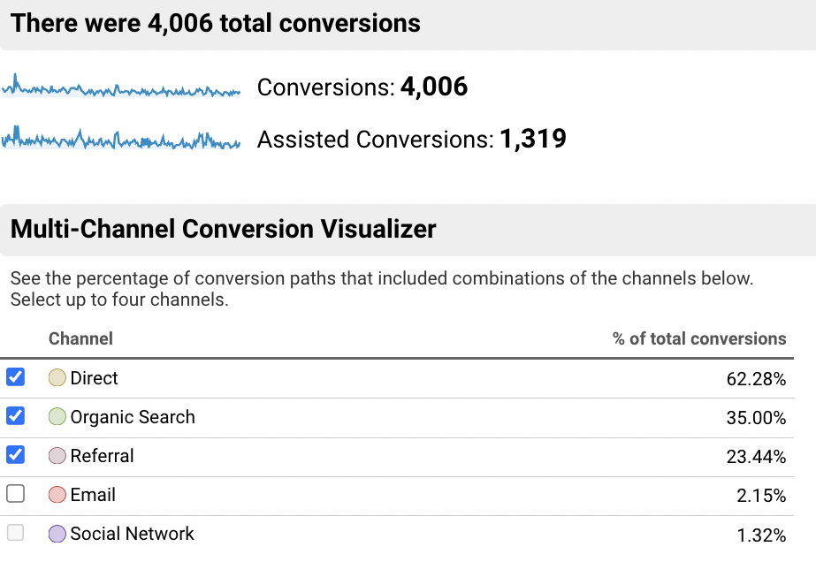 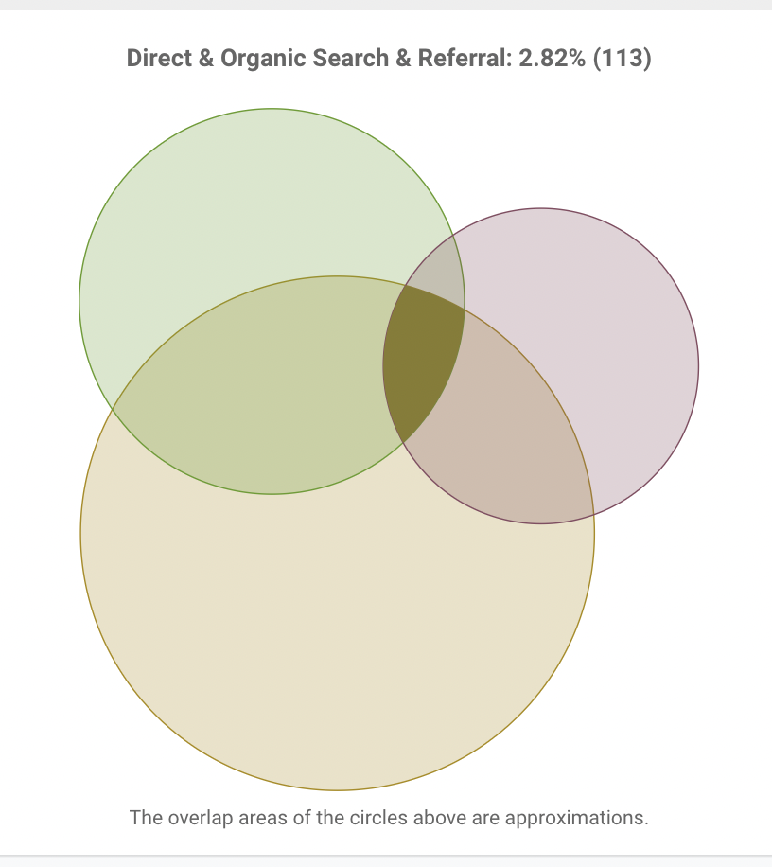

* Direct & Organic search & Referral overlap visually tells that the channels have only 2.82% which means 113 new users of NSTEM are from these combinations. As data shown, more users will prefer the direct marketing channel as the more conversions are generated from it since the last six months.
* On the other side, there is a significant rise in the number of new users with **Organic search** & **How to Start Chapter Page Visit (Goal 1 Completions) in NSTEM website.**

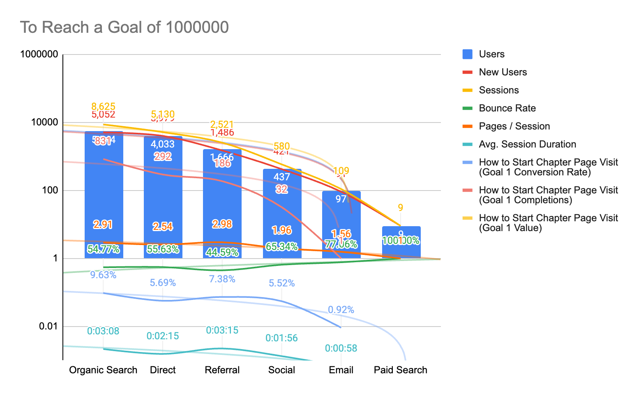

* Since the last six months of 2022, the session from users and new users combined get a consistent and significantly higher rate in **Organic search** channel.

January 22nd - 29th, 2023 ---------------------------------------------------------------------------------------------------------------------------

* From the January 2023 data, Organic search came to a leading position, generating 259 new users.

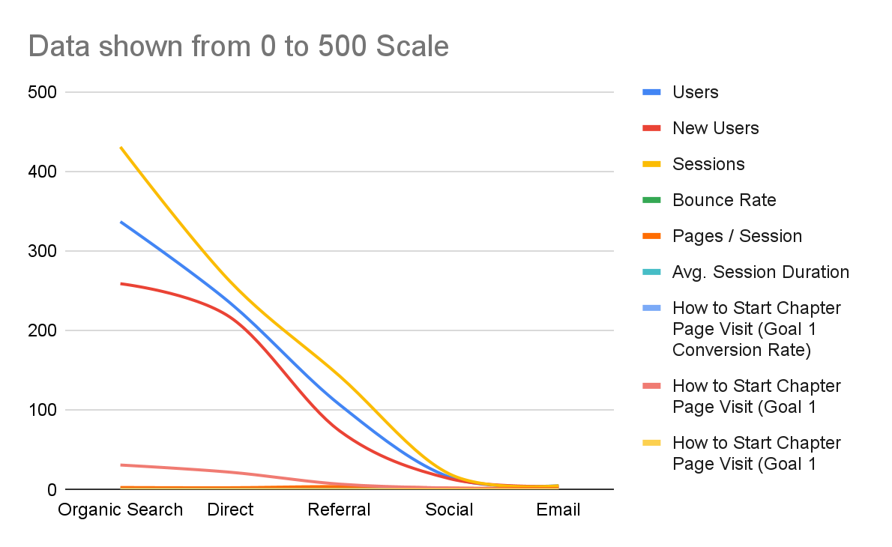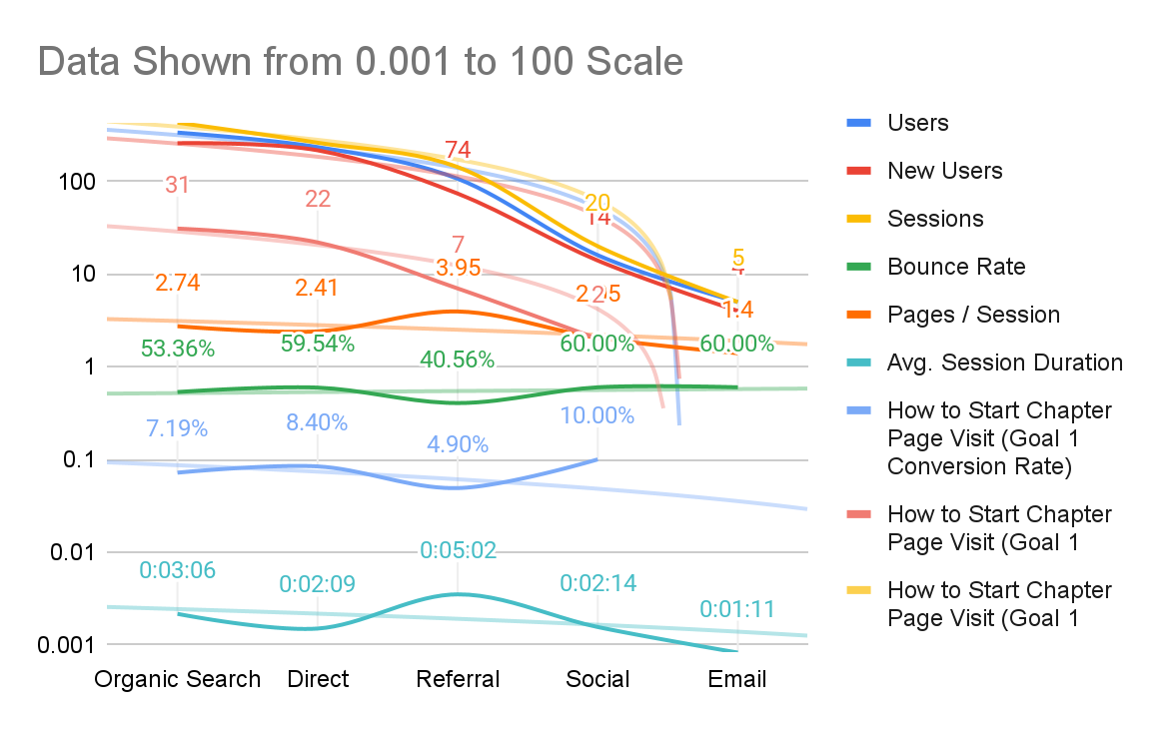

* Metrics, such as **How to Start Chapter Page Visit (Goal 1 Conversion Rate)** & **Average session duration** is off the grid scale. But the conversion rate and average session from Organic search and Referral is still on the trendline which will not be a negative motivation for NSTEM.

December 1st - 31st, 2022 —-----------------------------------------------------------------------------------------------------------

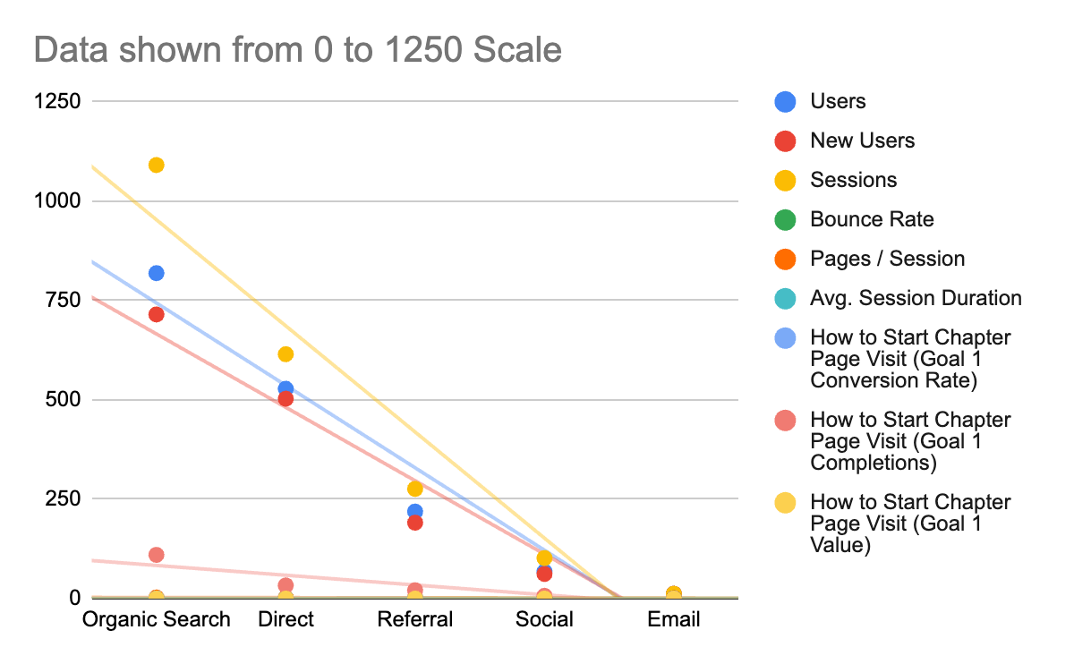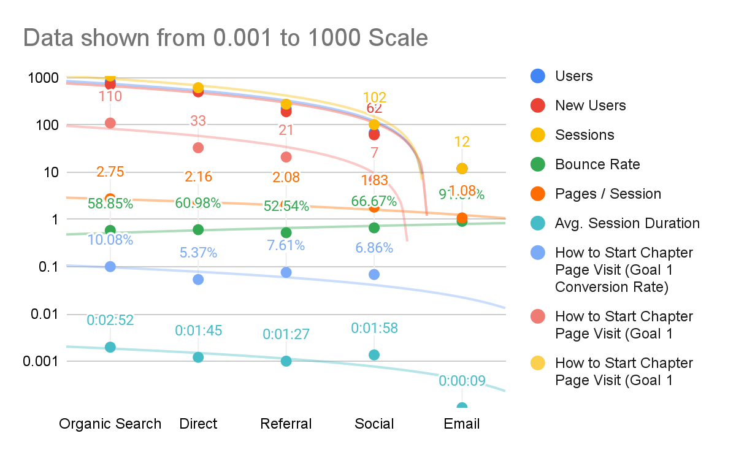

* December 2022, did not show an eye catching change. NSTEM user acquisition seems to be steady and static in terms of acquiring decent sessions by pages and new users. Comparison between January and December shows a correlation between channels Organic search and the direct marketing, as both channels seem to be the reliable and credible channels to reach more users.

# What NSTEM Should Continue Doing

* NSTEM Should introduce more subjects and create more referral links to increase the commonality between the channels. So, there will be more audience who can engage through different channels and thus NSTEM can increase its positive exposure and reliability.

# Ways to Improve the Website

* NSTEM can make improvements through Multi Channel Funnel Reporting (MCF).
* Create Custom Reporting about NSTEM audiences and sessions.
* Can create more segmentation for the audience base to get more insights.

# Data that Stands Out

From the analysis, the user acquisition is more Organic search and Direct Marketing driven for NSTEM. In general, the users are more protective towards the email as it is considered as one of the personal communication methods. Due to this reason, email marketing can lag behind from the platform. On the other side, social media showed no decent conversion value, which needs to be investigated more.

# Conclusion

To conclude, the most powerful channel to acquire more users is Organic search, a must. On the other hand paid search and social media needs to be emphasized as these hold a bigger portion with the audience.

Google Sheets:

<https://docs.google.com/spreadsheets/d/1SDpEzgB2tLvK_3fda6lkQm54AzC83R04N8XXcW_e2TI/edit?usp=sharing>